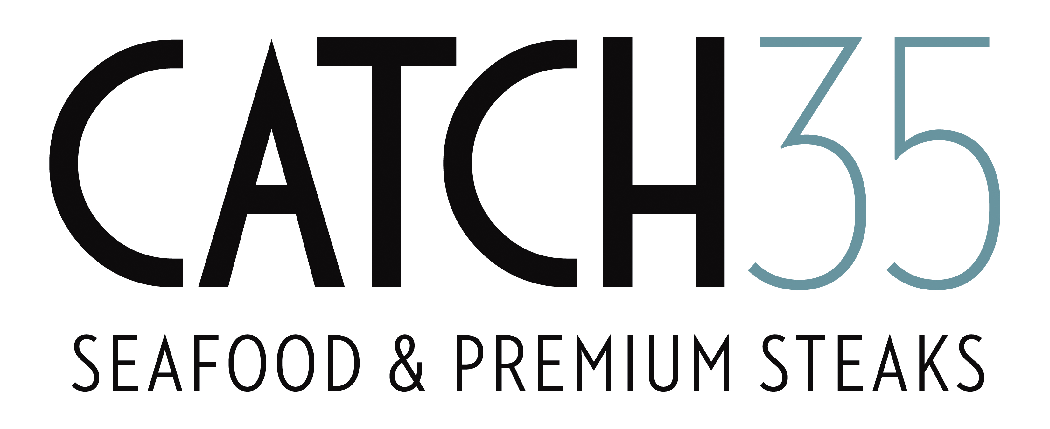

**Mardi Gras Specials**

**Fat Tuesday March 5th 2019**

**Seafood Gumbo 5/7**

Andouille sausage, dirty rice

**New Orleans Bbq Tabasco Shrimp & Clams 13**

Dirty rice, crostini

**Cajun Shrimp Po’boy 16**

Crispy cornmeal Florida Shrimp, shredded lettuce, tomatoes,

remoulade sauce, toasted hoagie bun

**Blackened Whitefish 19**

Pecan browned butter, dirty rice

Catch 35 Chicago 312.346.3500 Catch 35 Naperville 630.717.3500